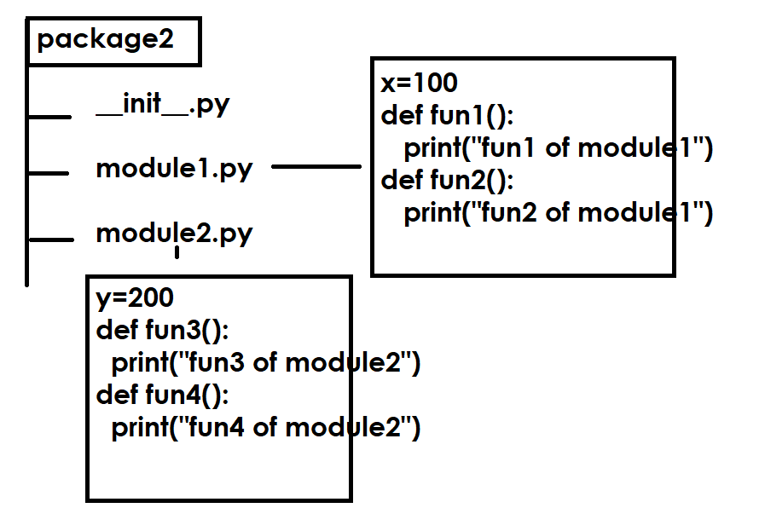
Write a program to use the content of package
import package2.module1
from package2 import module2
from package1.m1 import *
package2.module1.fun1()
package2.module1.fun2()
module2.fun3()
module2.fun4()
fun1()

Output
fun1 of module1 of package2
fun2 of module1 of package2
fun3 of module2 of package2
fun4 of module2 of package2
fun1 of m1 of package1

What is __init__.py?
__init__.py is called magic module and it is also called package configuration file or module.
This module is imported automatically when ever package is imported. This module is refers with package name.
This module is used for creating,
- Package level variables
- Package level functions
- Package level classes
- Hiding other modules and functionality

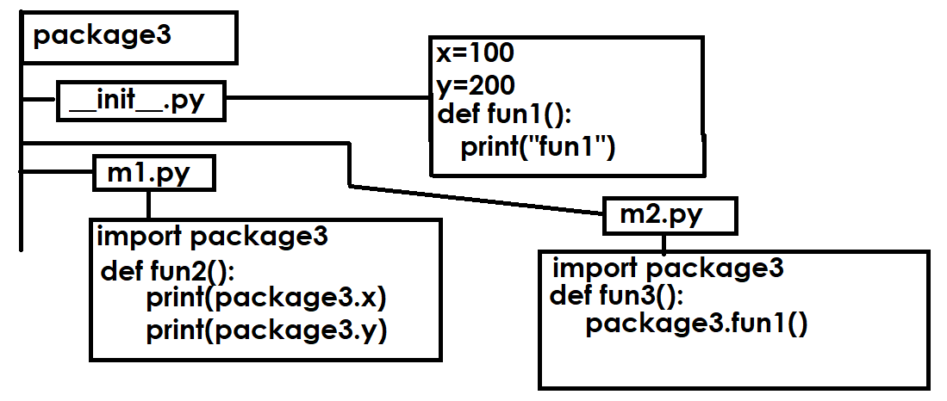
Write a program to test the package create a module outside the package

import package3
from package3 import m1,m2
print(package3.x)
print(package3.y)
package3.fun1()

m1.fun2()
m2.fun3()

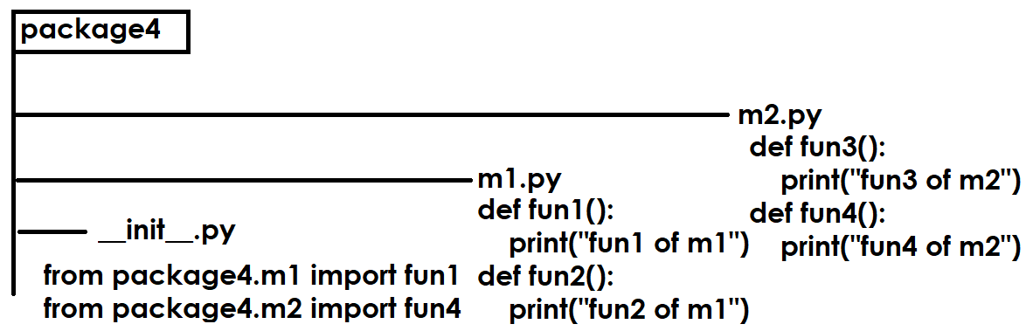

Write a program to test package, create program outside the package

import package4
package4.fun1()
package4.fun4()

Output
fun1 of m1
fun4 of m2

How to set module path?
sys.path
A list of strings that specifies the search path for modules. Initialized from the environment variable PYTHONPATH, plus an installation-dependent default.

Create a module and save in another location
In my system is saved inside d:\\backup

xmodule.py
def fun1():
print("fun1")

write a program to test, create this in other location
ptest.py
import sys
sys.path.append("d:\\backup")
import xmodule

xmodule.fun1()

How to manage predefined packages?
Predefined packages can be managed by using a predefined tool provided by python.

PIP command
PIP stands for preferred installer program
PIP stands for python installer package

Python software does not provide all the predefined packages, it will provides only standard packages but not provide application specific packages (numpy, pandas, keras, scipy, matplotlib, django, flask ,…)

installing the package

pip install package-name

all predefined packages are exists in a repository called www.pypi.org (Python Package Index)

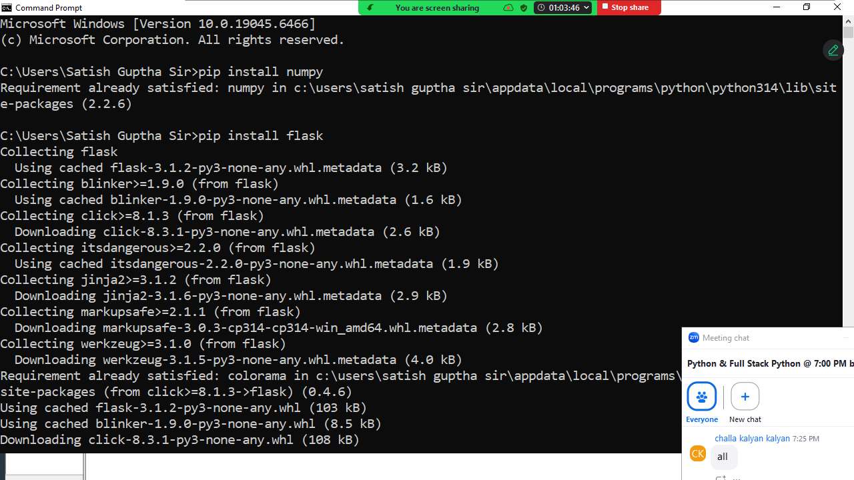

Listing installed packages

Installed packages can be viewed using,

Pip list

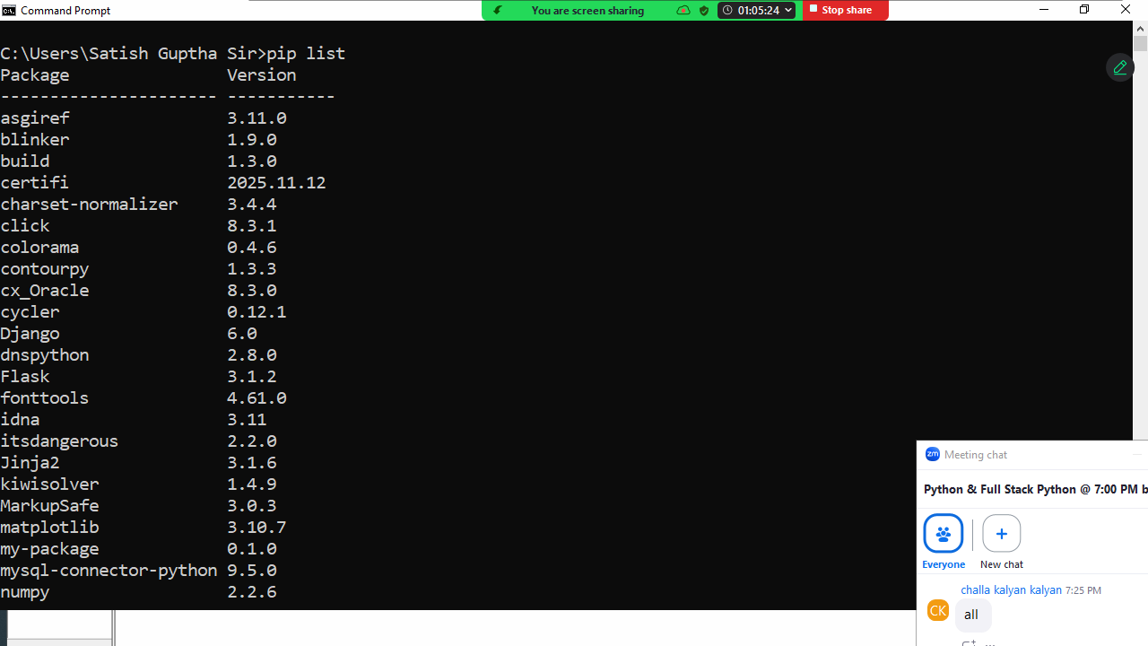

Uninstalling packages
Installed packages can be uninstalled using

pip uninstall packagename

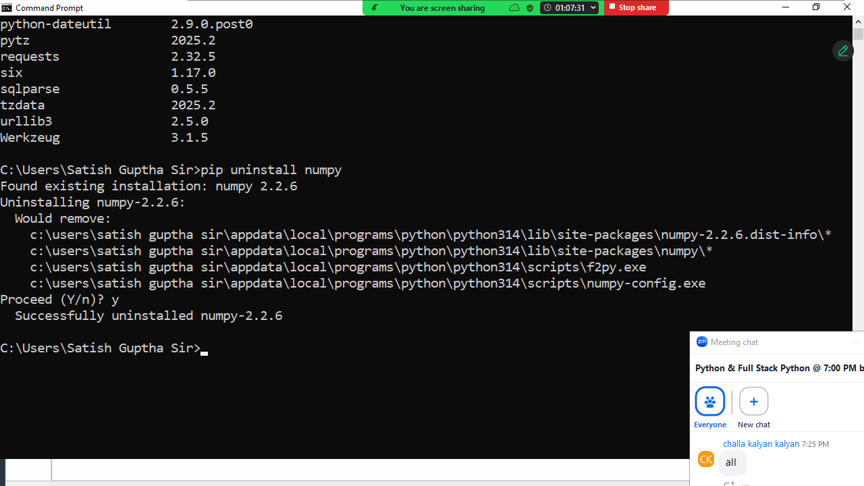

Displaying information about package

pip show package-name
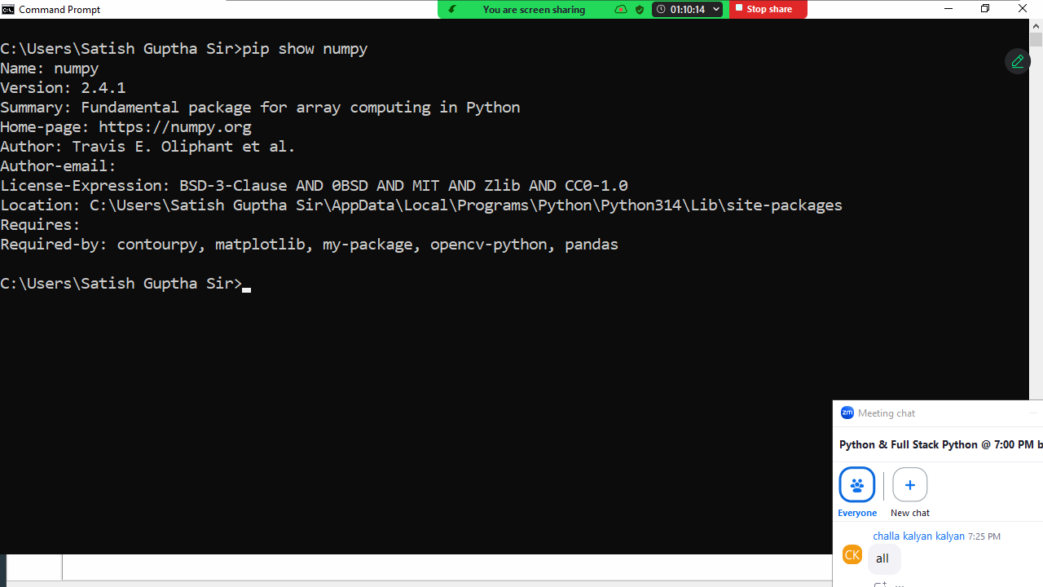

Object Oriented Programming (OOP)
The main objective of learning object oriented programming is creating user defined data types or building custom classes or data types.

Object Oriented Programming is not a language; it is a programming paradigm, which defines set of rules and regulations for building data types or classes.

Object oriented concepts
- Encapsulation
- Polymorphism
- Inheritance
- Abstraction
- Class
- Object

Python is object oriented programming language.
In object oriented programming languages data is represented as objects and every data type is class.

class
In object oriented programming a class represents data type.
Class is a collection of members and these members are 2 types
- Data members
- Member functions

